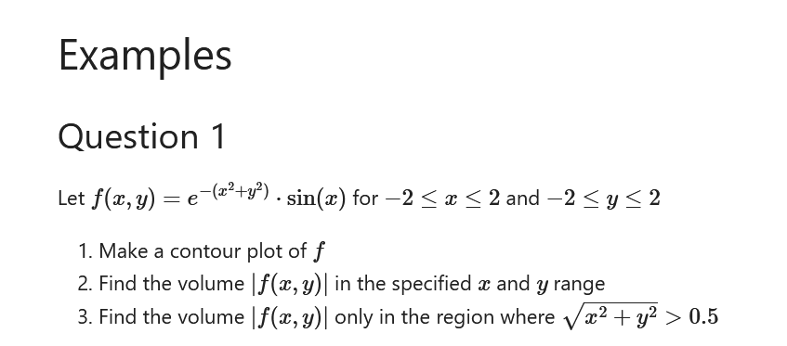

………………………………………….

x=np.linspace(-2,2,100)

y=np.linspace(-2,2,100)

xv,yv=np.meshgrid(x,y)

plt.xlabel('x',fontsize=20)

plt.ylabel('y',fontsize=20)

f = np.exp(-xv\*\*2-yv\*\*2) \* np.sin(xv)

plt.contourf(xv,yv,f, levels=10,color='plasma')

plt.colorbar()

#next part

v1=np.abs(f.ravel()).sum() \* np.diff(x)[0] \* np.diff(y)[0] #v=integration of (fdxdy)

print('volume1 =',v1)

#np.diff(x) # value of step size of x ,all equal because we are using meshgrid

#np.diff(y) #value of step size of x ,all equal because we are using meshgrid

v2=sum(np.abs(f[xv\*\*2+yv\*\*2>0.5\*\*2].ravel())) \* np.diff(x)[0] \* np.diff(y)[0]

print('volume2=',v2)

……………………………………………………………………………………………………….